DLD LAB REPORT

CLAP SWITCH CIRCUIT

MUHAMMAD MITWAS

(FA21-BCE-017)

**ABSTRACT:**

* What is clap switch circuit?
* What were the components used in this project?
* Working of the components.
* What was the logic for the circuit?
* What was the circuit diagram?
* What are the advantages.
* What is its effect on the society.

1. What is clap switch circuit?

A clap switch circuit is basically a circuit made which is controlled by sound of clap. It I used to ON/OFF anything by the help of a clap. A clap switch circuit can be used with light bulb, fans or any other appliances.

A clap switch circuit can respond to a clap, snapping of finger or you can even blow to it. It uses a mic that input a sound that operates whole circuit. It generally respond to a sound that is given to it.

1. What are the components.
2. LED bulb
3. Microphone
4. Resistors
5. Transistor (BC 547)
6. IC (4017)
7. Battery (9V)
8. Wires
9. Relay
10. Bulb
11. Holder

Mic:

A microphone is an input device.

It will be used to detect any sound produced by clapping of hands or snapping of fingers.

The microphone will convert the sound energy into electrical energy and give it as a input to the circuit.

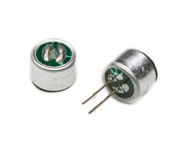

Transistors:

BC 547 is used to amplify the signals. It is an NPN transistor. It consists of a base, collector and emitter.

Emitter : Emitter “emits” electrons into the base.

Base : Base controls the number of electrons the emitter emits.

Collector : Most of the electrons are collected by the collector which sends along them to the next part of the circuit.

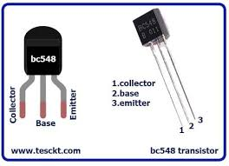

IC 4017:

Working of 4017 IC.

8th pin is ground pin, while 16th pin is Voltage supply pin.

1 to 7 and 9 to 11 are output pins.

13th pin is enable, 14th is clock pin, 15th is reset pin, 12th is carryout.

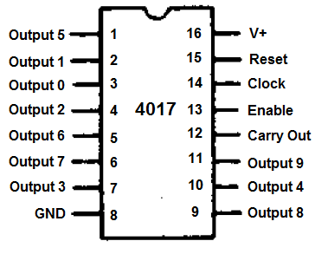

Relay:

* A relay is an electrically operated switch . which has a coil in it
* It consists of 5 pins.
* 2 pins are connected to coil 1 pin is common 1 is normally open and other is normally closed.
* When current passes through the coil it produces magnetic field, which breaks the connection of one terminal to and connect it to other terminal from which current flows.

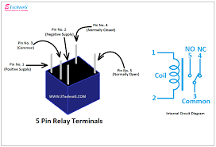

Circuit diagram:

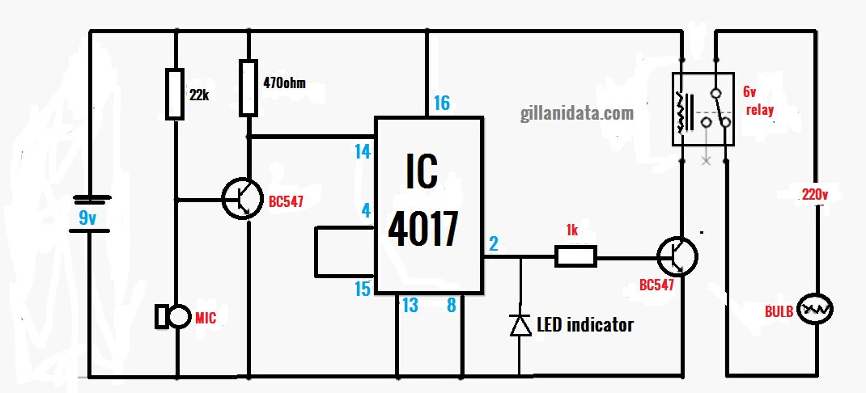

Working:

First of all a noise will be input through the mic. The mic will convert sound energy into electrical energy. Then it will go to the transistor. The transistor will amplify the energy and will send it to then 14th pin of IC. 14 is the clock pin. Then an output pin be connected to a resistor, 1 pin of the resistor will connect to the base of the transistor. An led bulb will be used whose 1 pin will be connected to resistor and other one will be connected to the collector of the transistor. The it will go to the relay and it will light up the bulb.

Advantages on the society:

It has many advantages and positive impacts on the society:

1. It helps disabled persons to access anything with help of a sound.
2. It can be used for security purposes.
3. It will help blind people to turn ON/OFF fan.
4. It will be affordable.